Visual Programming Project  
(Hospital System)

Amro Dara- B2205.010017-SECTION(1)  
Osamah Rabi-B2105.010045-SECTION(1)

This project will include

an authentication and a CRUD form  
along with a third form where a patient can sign up and have a treatment for his/her diagnostics

This is a picture of the CRUD form database design:

صورة تحتوي على منضدة

تم إنشاء الوصف تلقائياً

This is a picture of the admin authentication database design:

صورة تحتوي على منضدة

تم إنشاء الوصف تلقائياً

This class makes a connection to the database and creates several methods which we later use in the project such as: the SELECT method , the INSERT method, the UPDATE method, the DELETE method

Database connection

صورة تحتوي على نص

تم إنشاء الوصف تلقائياً

As shown in the picture the connection to the database that’s taken from the appconfig and the methods mentioned above also the libraries we used in all of the forms.

SELECT METHOD

صورة تحتوي على نص

تم إنشاء الوصف تلقائياً

INSERT METHOD

صورة تحتوي على نص

تم إنشاء الوصف تلقائياً

UPDATE METHOD

صورة تحتوي على نص

تم إنشاء الوصف تلقائياً

DELETE METHOD

صورة تحتوي على نص

تم إنشاء الوصف تلقائياً

This is a picture of Form1 which is the login form:-

Figure 1)



This form contains two textboxes and two buttons :-

textbox1 for entering username information.

textbox2 for entering password information.

button1 for signing into the CRUD Form.

button2 for entering the sign up Form.

Button1 takes the data from the admin table in the database and checks if they are correct , if they are correct it logs in to the second form which is the CRUD form and if its not correct it displays a message saying “Access is denied”.

CODE for button1:

صورة تحتوي على نص

تم إنشاء الوصف تلقائياً

Here we used a select method to receive the data from the admin datatable

صورة تحتوي على نص, لقطة شاشة, شاشة

تم إنشاء الوصف تلقائياً

Here we created a method that checks if the username and password rows in the datatable exists or not , if it exists it returns true and if not it returns false.

صورة تحتوي على نص

تم إنشاء الوصف تلقائياً

Here inside the button click code we check if the method “isExist” is true or not by calling it, if its true we hide form1 and open form2 which is the CRUD form, if its not true we display a message saying ”access denied”.

Button2 click opens form3 which is the patient sign up form:

صورة تحتوي على نص

تم إنشاء الوصف تلقائياً

This is a picture of Form2 which is the CRUD form:

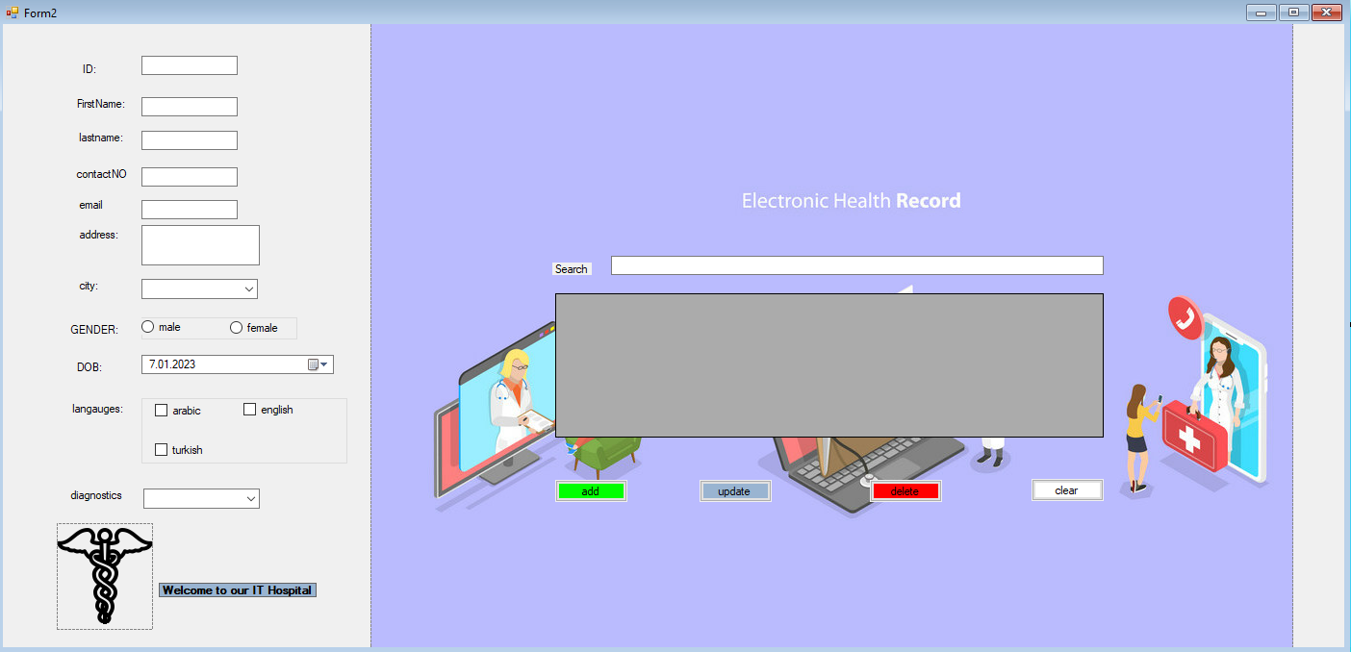

This form allows us to control every user from from the database , we can add, update or delete users however we want.

This form contains five textboxes plus a 6th multiline textbox, two combo boxes, two radio buttons inside a group box, date and time picker, three checkboxes inside a group box.

“txtpatientID“ , ”txtfirstname”,”txtlastname”,”txtcontactNO”,”txtemail” and ”txtaddress”.

“cbocity” and “cboxdiagn”.

“groupBox1” that contains “rdomale” and “rdofemale”.

“groupBox2” that contains “cbarabic” , ”cbenglish” and “cbturkish”.

Lastly “datetpDOB” .

Also a data grid view “DGVpatient” that displays all the rows of the patient table in the database.

a Searchbar “txtsearchbox” that searches for firstname or lastname of the patient inside the grid view.

صورة تحتوي على نص

تم إنشاء الوصف تلقائياً

Theres four buttons in the form :- “btnadd” , “btnupdate” , “btndelete” and “btnclear”

btnadd which adds the data entered in the form controls into the database and the data grid view.

صورة تحتوي على نص

تم إنشاء الوصف تلقائياً

Rowheaderdoubleclick allows me to show everything inside the database to appear in the form controls when we double click on the row header.

صورة تحتوي على نص

تم إنشاء الوصف تلقائياً

btnupdate which after selecting the cell by double clicking on its row and letting them appear on the form controls , we are allowed to change them by clicking the update button:

صورة تحتوي على نص

تم إنشاء الوصف تلقائياً

btndelete which after selecting the cell by double clicking on its row ,we are able to delete the cell and all of its contains by clicking the delete button:

صورة تحتوي على نص

تم إنشاء الوصف تلقائياً

btnclear lets us clear the form controls from data written beforehands and as u can see its used in every button function

صورة تحتوي على نص

تم إنشاء الوصف تلقائياً

The clear method :-

صورة تحتوي على نص

تم إنشاء الوصف تلقائياً

When we load Form2, we show the content of the patientDB table inside the data grid view by using the SELECT method we have in our patientclass.

صورة تحتوي على نص

تم إنشاء الوصف تلقائياً

This is a picture of Form3 which is the singup form:



This form allows us to create a user (patient) without being an admin and it adds the information of this user to the database and also it gives us the recommended treatment for the chosen diagnosis.

This form contains four textboxes plus a 5th multiline textbox, two combo boxes, two radio buttons inside a group box, date and time picker, three checkboxes inside a group box.

“txtpatientID2“ , ”txtfirstname2”,”txtlastname2”,”txtcontactNO2”,”txtemail2” and ”txtaddress2”.

“cbocity2” and “cboxdiagn2”.

“groupBox1” that contains “rdomale2” and “rdofemale2”.

“groupBox2” that contains “cbarabic2” , ”cbenglish2” and “cbturkish2”.

Lastly “datetpDOB2” .

This form has only one button which is the sign up button(“signupbtn”)

This button takes every data on the form and inserts it to the database.

First of all :-

Assigning our class to a variable {std} and using the clear method so we clear every data when we are done:

صورة تحتوي على نص

تم إنشاء الوصف تلقائياً

صورة تحتوي على نص

تم إنشاء الوصف تلقائياً

صورة تحتوي على نص

تم إنشاء الوصف تلقائياً

This is a method we are using so when a patient chooses his diagnostics , he will receive the recommended treatment as a message box.

صورة تحتوي على نص

تم إنشاء الوصف تلقائياً

This sign up button uses the insert method from the class to insert everything to the database and then we used the call function for :(diagno) so after inserting the data into the database, the patient gets to see the recommendations for his treatment. After that we use the clear method (Clear) to clear everything in the controls.